ITA0515
Computer Vision Lab Programs (21 - 25)

Y. Jayesh Ranjan
192472201

EXP 21
Aim
To sharpen an image using a Laplacian mask with an extension of diagonal neighbors.

Algorithm
- Import the OpenCV and NumPy libraries.
- Read the input image.
- Create the Laplacian kernel.
- Apply the kernel to the image.
- Display the original and sharpened images.
- Save the sharpened image.

Code
import cv2
import numpy as np

image = cv2.imread("image1.jpg")

kernel = np.array([[1, 1, 1],
[1, -8, 1],
[1, 1, 1]])

sharpened = cv2.filter2D(image, -1, kernel)

cv2.imshow("Original Image", display_original) cv2.imshow("Sharpened Image", display_sharpened)

cv2.imwrite("sharpened_image.jpg", sharpened)

cv2.waitKey(0) cv2.destroyAllWindows()

Input
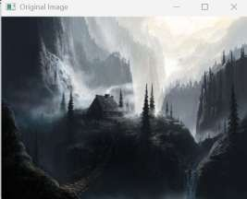
Output
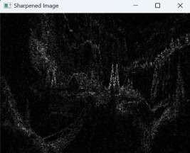

Result
Thus, the program to sharpen an image using a Laplacian mask with diagonal neighbors was executed successfully.

EXP 22

Aim
To sharpen an image using a Laplacian mask with a positive center coefficient.

Algorithm
- Import the OpenCV and NumPy libraries.
- Read the input image.
- Create the Laplacian kernel.
- Apply the kernel.
- Display the original and sharpened images.
- Save the sharpened image.

Code
import cv2
import numpy as np

image = cv2.imread("image1.jpg")

kernel = np.array([[0, 1, 0],
[1, -8, 1],
[0, 1, 0]])

sharpened = cv2.filter2D(image, -1, kernel)

cv2.imshow("Original Image", display_original) cv2.imshow("Sharpened Image", display_sharpened) cv2.imwrite("positive_laplacian.jpg", sharpened) cv2.waitKey(0)
cv2.destroyAllWindows()

Input
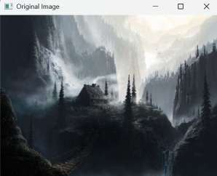
Output
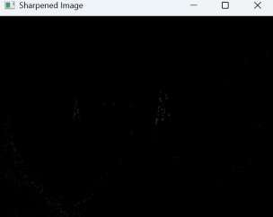

Result
Thus, the program to sharpen an image using a Laplacian mask with a positive center coefficient was executed successfully.

EXP 23

Aim
To sharpen an image using the Unsharp Masking technique.

Algorithm
- Import the PIL library.
- Read the input image.
- Apply the Unsharp Mask filter.
- Display the sharpened image.
- Save the output image.

Code
from PIL import Image, ImageFilter

image = Image.open("image1.jpg")

output = image.filter(ImageFilter.UnsharpMask(radius=3,
percent=200, threshold=5))

output.show()

output.save("unsharp_image.jpg")

Input
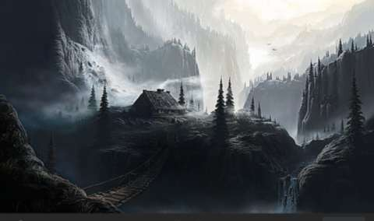
Output
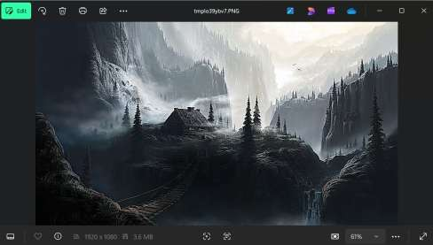

Result
Thus, the program to sharpen an image using the Unsharp Masking technique was executed successfully.

EXP 24

Aim
To sharpen an image using the High-Boost Mask technique.

Algorithm
- Import the OpenCV and NumPy libraries.
- Read the input image.
- Blur the image.
- Create the high-boost mask.
- Sharpen the image.
- Display the original and sharpened images.
- Save the sharpened image.

Code
import cv2
import numpy as np
def high_boost(image, factor):
blur = cv2.GaussianBlur(image, (3, 3), 0)
return cv2.addWeighted(image, factor, blur, -(factor - 1), 0) image = cv2.imread("image1.jpg")
sharpened = high_boost(image, 1.5) display_original = cv2.resize(image, (400, 300))
display_sharpened = cv2.resize(sharpened, (400, 300)) cv2.imshow("Original Image", display_original) cv2.imshow("High Boost Image", display_sharpened) cv2.imwrite("high_boost.jpg", sharpened)

cv2.destroyAllWindows() Input
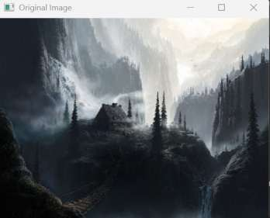
Output
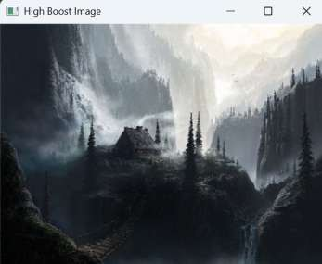

Result
Thus, the program to sharpen an image using the High-Boost Mask technique was executed successfully.

EXP 25

Aim
To sharpen an image using the Gradient Masking technique.

Algorithm
- Import the OpenCV library.
- Read the input image.
- Convert the image to grayscale.
- Apply the Sobel operator in the X and Y directions.
- Generate the gradient image.
- Display the original and gradient images.
- Save the gradient image.

Code
import cv2
image = cv2.imread("image1.jpg")
gray = cv2.cvtColor(image, cv2.COLOR_BGR2GRAY) gradient_x = cv2.Sobel(gray, cv2.CV_64F, 1, 0, ksize=3) gradient_y = cv2.Sobel(gray, cv2.CV_64F, 0, 1, ksize=3) gradient = cv2.subtract(gradient_x, gradient_y)
gradient = cv2.convertScaleAbs(gradient) display_original = cv2.resize(image, (400, 300))
display_gradient = cv2.resize(gradient, (400, 300)) cv2.imshow("Original Image", display_original) cv2.imshow("Gradient Image", display_gradient) cv2.imwrite("gradient_image.jpg", gradient)

cv2.destroyAllWindows() Input
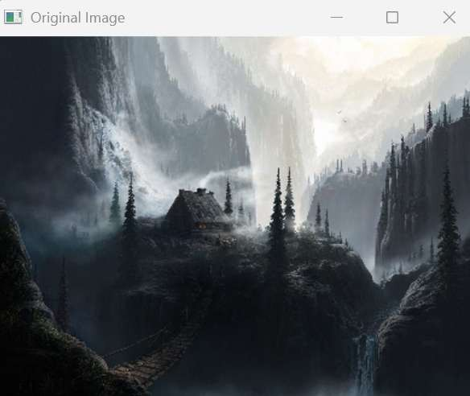
Output
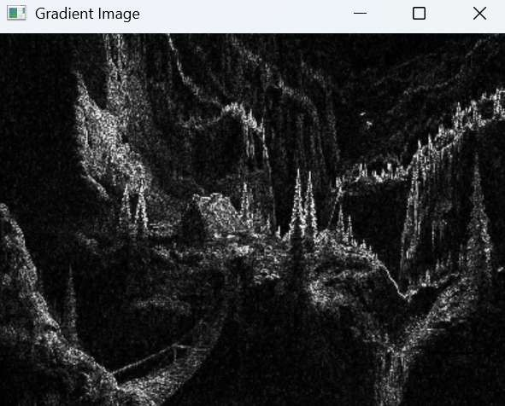

Result
Thus, the program to sharpen an image using the Gradient Masking technique was executed successfully.

